Bidu Sayão

From Wikipedia, the free encyclopedia
Jump to: navigation, search
Bidú Sayão (Itaguaí, May 11, 1902 - March 12, 1999 ^{[1]} ^{[2]}) was Brazil's most famous opera singer and one of the great stars of the Metropolitan Opera for fifteen years (1937-1952).

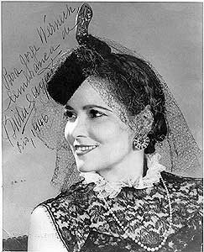

Contents
[hide]
- 1 Life and career
  - 1.1 A star at the Metropolitan Opera
  - 1.2 Bidu Sayao & Elena Teodorini
- 2 Bibliography
- 3 References

[edit] Life and career
Bidú Sayão was born Balduína de Oliveira Sayão to a cultured family in Botafogo, Rio de Janeiro. Her father died when she was five years old and her mother struggled to support her daughter's costly pursuit of a singing career. At the age of only eighteen, the gifted Bidu Sayão made her major opera debut in Rio de Janeiro. Her acclaimed performance led to an opportunity to study with the famous Elena Teodorini, first in Brazil and then in Romania; and then to study with the renowned Polish tenor and tutor, Jean de Reszke, in Nice. During the mid 1920s and early 1930s, she performed in Rome, Buenos Aires, Paris, as well as in her native Brazil. While at the Teatro Costanzi in Rome, she met impresario Walter Mocchi (1870-1955). After his wife, soprano Emma Carelli, died in 1928, the two became romantically involved and were married. However, it did not last and in 1935 Sayão married the Italian baritone, Giuseppe Danise (1883-1963).
In 1930, she debuted at the Teatro alla Scala in Milan, and in the next year she sang a successful Juliette, in Gounod's Roméo et Juliette, at the Paris Opera. In the same year, she gained a great success with her debut at the Opéra Comique as Lakmé. She soon became one of the leading lyric coloratura sopranos in Europe, especially in Italy and France. Her repertoire included Lucia di Lammermoor, Amina in La Sonnambula, Elvira in I Puritani, Zerbinetta in Ariadne auf Naxos and Cecilia in Il Guarany, among other roles.
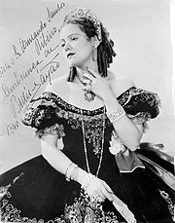
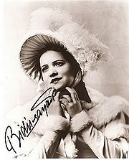

[edit] A star at the Metropolitan Opera
Bidu Sayão made her US debut in a recital at Town Hall in New York City on December 30, 1935. Her US operatic debut followed not long thereafter, on January 21, 1936, when she and Danise sang in the penultimate production of the Washington National Opera, a semi-professional company not associated with its modern namesake; the performance, of Léo Delibes's Lakmé, was marred by a fractious dispute in which the orchestra musicians declined to play without payment in cash, and ultimately the performance was accompanied by a portable organ, with some singers appearing in costume and some in street clothes owing to a similar demand by the stage hands and costume man.^{[3]} Altogether more dignified was her performance a few months later with the New York Philharmonic at Carnegie Hall singing La Demoiselle élue by Debussy. Her performance was under the baton of Arturo Toscanini who would become her greatest supporter and lifelong friend. She sang her first performance at the Metropolitan Opera as Manon on February 13, 1937, replacing the Spanish soprano Lucrezia Bori. The critics, including Olin Downes of the New York Times[1], raved about her performance and within a few weeks she was given the lead in La Traviata, followed soon thereafter by Mimì in La Bohème. She also contributed to the Mozart revival at the Metropolitan Opera, becoming the preëminent Zerlina (Don Giovanni) and Susanna (Le Nozze di Figaro) of her generation.
As the favorite singer of Brazilian composer Heitor Villa Lobos, she had an artistic partnership with him that lasted many years and made a number of recordings of his compositions, including a famous recording of the Bachianas Brasileiras No. 5.

Bidu Sayão and her husband Giuseppe Danise purchased an oceanfront property in Lincolnville, Maine. After fifteen years with the Metropolitan Opera, she gave her last performance in 1952, choosing to retire from opera while still at the top of her form. For the next two years she was a guest performer throughout the U.S., but in 1957 she decided to retire completely from public performance; two years after that she made her final recording as the soprano soloist on Heitor Villa Lobos' world premiere stereo recording of his cantata Forest of the Amazon with the composer conducting the Symphony of the Air.
Following the death of her husband in 1963, Bidu Sayão lived a quiet life at her home in Maine. She returned to visit Brazil a last time in 1995, for a tribute to her during the Carnival in Rio de Janeiro, and died a few years later at the Penobscot Bay Medical Center in Rockport, Maine. Her ashes were scattered across the Bay in front of her home.
Although Brazilians have always been strong patrons of the opera, at the time Bidu Sayão was struggling to launch her career there was little in the way of government assistance for aspiring singers; throughout her life she spoke about this lack of support. Following her last visit to her homeland, the government prepared plans to honor her memory. In 2000 the Bidu Sayão International Vocal Competition was established to promote Brazilian operatic talent through a world-class competition.
Bidu Sayão's portrait hangs in the lobby at the Metropolitan Opera House in New York City.
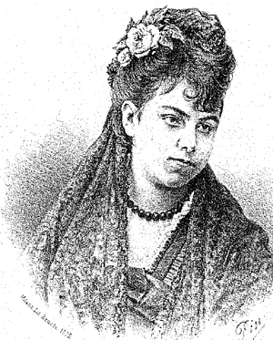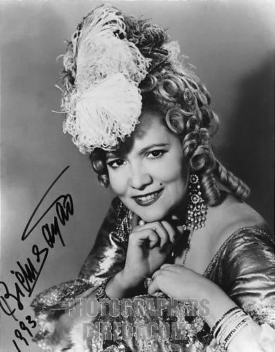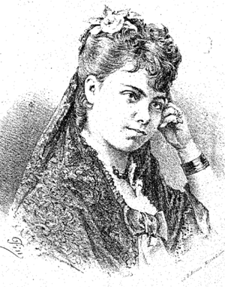

[edit] Bidu Sayao & Elena Teodorini
“ Stubborn and spoiled, I insisted on having the best teacher available. but Elena Teodorini, the great Rumanian soprano who had sung at La Scala and was settled in Rio giving lessons, she had no intention of taking me as a pupil. I was too young, in the firs place, and the voice much too small. I pleaded and pleaded, and managed to make myself such a nuisance that I broke down her resistance and she accepted me . eventually she became impressed by my willpower and discipline. I soon realized that there was no way to become a singer without a solid musical background, and so I trained in all areas. By my third year it was obvious that I was a coloratura; I hit a G with facility, and the picchettati came without effort.
Than, suddenly , a major problem arose. Madame Teodorini had decided that the time had come for her to return to her native Rumania, and I would not hear of changing teacher. So, after many discussions at home, I followed her Rumania , where dreams began to come true. The stunning Queen Marie was an indefatigable patroness of music and, after hearing me, chose me to be soloist with the orchestra at a concert given in the palace for the official visit of Hirohito, at that time crown price of Japan. Despite being extremely nervous, I made out very well”.

[edit] Bibliography
- The Last Prima Donnas, by Lanfranco Rasponi, Alfred A Knopf, Bidu Sayao, pp. 507, 1982. ISBN 0-394-52153-6

[edit] References
- ^ Bourdain, Gladys (March 13, 1999). "Bidu Sayao, 94, Star Soprano of the 30's and 40's, Dies". The New York Times. http://www.nytimes.com/1999/03/13/arts/bidu-sayao-94-star-soprano-of-the-30-s-and-40-s-dies.html. Retrieved 2009-10-25.
- ^ New York Times Obituary
- ^ McPherson, Jim, "Mr. Meek Goes to Washington: The Story of the Small-Potatoes Canadian Baritone Who Founded America’s 'National' Opera," The Opera Quarterly, volume 20, no. 2, Spring 2004
4. http://www.excitingbrazil.com/bidusayao.html
5. http://images.google.ro/images?hl=ro&source=hp&q=bidu+sayao&um=1&ie=UTF- 8&ei=BmNlS5zhI5yCmwOonbAW&sa=X&oi=image_result_group&ct=title&resnum=4&ved=0CC8QsAQwAw
6. http://images.google.ro/imgres?imgurl=http://1.bp.blogspot.com/_6s3UHpzn9lg/SR3rceCIVdI/AAAAAAAAA7Q/gn8GbzGr2Qg/s200/teodorini-g.gif&imgrefurl=http://brazilia-romania.blogspot.com/2008_11_01_archive.html&usg=__q8Lc2olvT4ojoOhPTqxrhA3Y838=&h=200&w=157&sz=57&hl=ro&start=138&sig2=f4HBT3MqS8eDawcFOZdYMw&um=1&tbnid=_kvBApak6yZDyM:&tbnh=104&tbnw=82&prev=/images%3Fq%3Dbidu%2Bsayao%26ndsp%3D20%26hl%3Dro%26sa%3DN%26start%3D120%26um%3D1&ei=emRlS9CFEIu-mQO__4kk
7. http://www.last.fm/music/Bidu+Say%C3%A3o
8. http://www.youtube.com/watch?v=LNHf26uNfok
9. http://www.youtube.com/watch?v=e_3XwdpyeNo&feature=related
10. http://www.youtube.com/watch?v=i4LJIuNgjxg&feature=related
11. http://www.youtube.com/watch?v=EZCTYN772w0&feature=related
12. http://www.youtube.com/watch?v=E_repFV7pms&feature=related
13. http://www.youtube.com/watch?v=AgmDtluhpe4&NR=1
14. http://www.youtube.com/watch?v=BtGGM1RbDtw&feature=related
15. http://www.youtube.com/watch?v=bLZD0XplYrI&feature=related
16 http://www.youtube.com/watch?v=ePxoYqknR1I&feature=related

