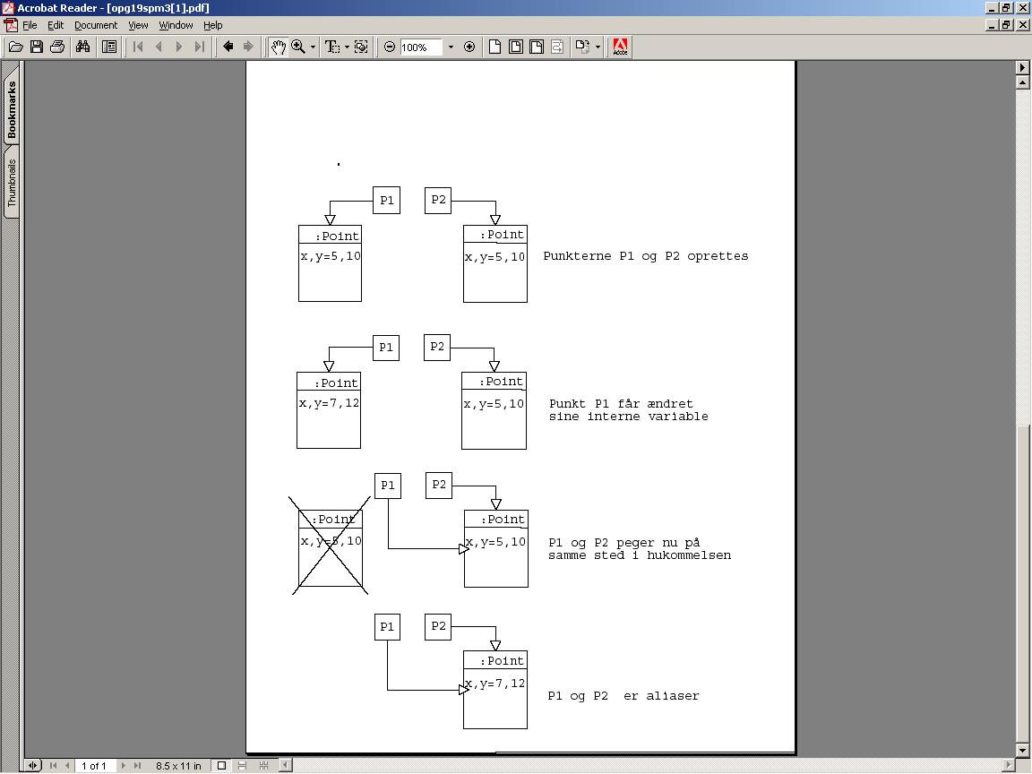

The points P1 and P2 are initialized.

P1’s internal variables are changed.

P1 and P2 point at the same place in the memory (They are aliases).

P1’s internal variables are changed, and that also changes P2 variables, as they are aliases.

